Week 5 – Market Basket Analysis

Implementing Apriori algorithm in Python

Dr Gopal Jamnal

Practical Tutorial:
Apriori Algorithm is a Machine Learning algorithm which is used to gain insight into the structured relationships between different items involved. The most prominent practical application of the algorithm is to recommend products based on the products already present in the user’s cart.

Note : Please make sure you take care of tab, commas, brackets while copying and pasting codes in pycharm. INSTALL PACKAGES carefully.

Install dependencies before starting:

pip install mlxtend pandas numpy
Dataset : Groceries data Implementation of algorithm in Python:
Step 1: Importing the required libraries
import numpy as np import pandas as pd
from mlxtend.frequent_patterns import apriori, association_rules

Step 2: Loading and exploring the data

# Change the file path location as per your settings
# Loading the Data
data = pd.read_csv('Online_Retail.xlsx') print(data.head())
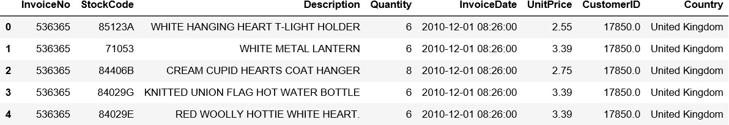
print(data.info())

Your Task :
- How many transactions and products are in the dataset?
54109
- Which columns seem useful for association rule mining?

# Exploring the columns of the data
Print(data.columns)

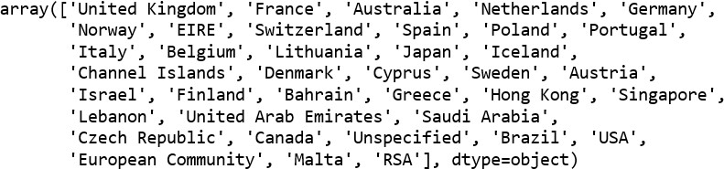
# Exploring the different regions of transactions print(data.Country.unique())

Step 3: Cleaning the Data

# Stripping extra spaces in the description data['Description'] = data['Description'].str.strip()

# Dropping the rows without any invoice number data.dropna(axis = 0, subset =['InvoiceNo'], inplace = True)

# Convert invoice numbers to string
data['InvoiceNo'] = data['InvoiceNo'].astype('str')

# Dropping all transactions which were done on credit data = data[~data['InvoiceNo'].str.contains('C')]

Your tasks:
- Why is it important to remove transactions with “C”?
Non numerical
- How might missing invoices affect the model?
Develop a skew in the model

Step 4: Splitting the data according to the region of transaction

# Transactions done in France
basket_France = (data[data['Country'] =="France"]
.groupby(['InvoiceNo', 'Description'])['Quantity']
.sum().unstack().reset_index().fillna(0)
.set_index('InvoiceNo'))
print(basket_France.shape)
Task:
- How many unique products do you think France sells?”
1563

# Transactions done in the United Kingdom
basket_UK = (data[data['Country'] =="United Kingdom"]
.groupby(['InvoiceNo', 'Description'])['Quantity']
.sum().unstack().reset_index().fillna(0)
.set_index('InvoiceNo'))
print(basket_UK.shape)
Task:
- How many unique products do you think UK sells?”
4176

# Transactions done in Portugal
basket_Por = (data[data['Country'] =="Portugal"]
.groupby(['InvoiceNo', 'Description'])['Quantity']
.sum().unstack().reset_index().fillna(0)
.set_index('InvoiceNo'))

Print(basket_Por.shape)

Task:
- How many unique products do you think Portugal sells?”
713
# Transactions done in Sweden
basket_Sweden = (data[data['Country'] =="Sweden"]
.groupby(['InvoiceNo', 'Description'])['Quantity']
.sum().unstack().reset_index().fillna(0)
.set_index('InvoiceNo'))
print(basket_Sweden.shape)
Task:
- How many unique products do you think Sweden sells?”
261

Step 5: Hot encoding the Data

# Defining the hot encoding function to make the data suitable # for the concerned libraries
def hot_encode(x):
if(x<= 0):
return 0
if(x>= 1):
return 1

# Encoding the datasets for each country basket
basket_encoded = basket_France.applymap(hot_encode)

basket_France = basket_encoded

Your task:

- Can you do the rest for UK, Portugal and Sweden ?

Step 6: Building the Apriori model and analyzing the results
# Building the model for France
frq_items = apriori(basket_France, min_support = 0.05, use_colnames = True)
# Collecting the inferred rules in a dataframe
rules = association_rules(frq_items, metric ="lift", min_threshold = 1)

# Sort and display strongest rules
rules = rules.sort_values(['confidence', 'lift'], ascending =[False, False]) print(rules.head(10))
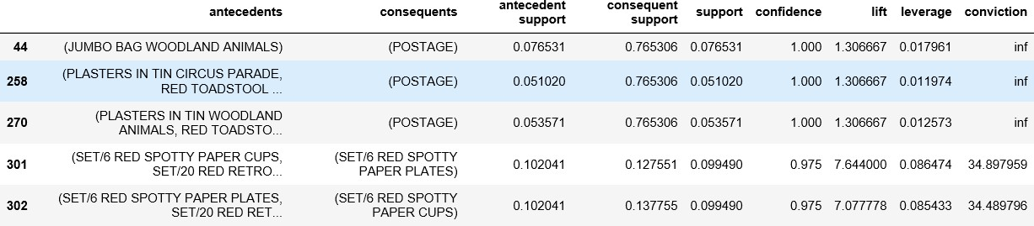

Task:
- “Which items do you expect to appear together most often in France ?”

From the above output, it can be seen that paper cups and paper and plates are bought together in France. This is because the French have a culture of having a get-together with their friends and family atleast once a week. Also, since the French government has banned the use of plastic in the country, the people have to purchase the paper-based alternatives.

Also, you can try different values in min_support to see if it gives you various different rules.

United Kingdom:

frq_items = apriori(basket_UK, min_support = 0.01, use_colnames = True)

rules = association_rules(frq_items, metric ="lift", min_threshold = 1) rules = rules.sort_values(['confidence', 'lift'], ascending =[False, False]) print(rules.head())
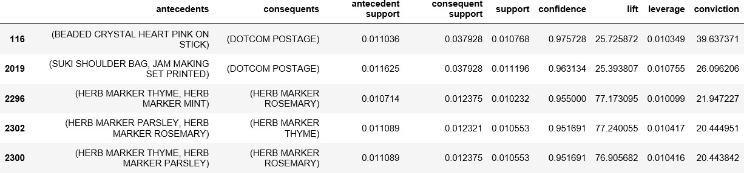

If the rules for British transactions are analyzed a little deeper, it is seen that the British people buy different colored tea-plates together. A reason behind this may be because typically the British enjoy tea very much and often collect different colored tea-plates for different occasions.

Portugal:
frq_items = apriori(basket_Por, min_support = 0.05, use_colnames = True) rules = association_rules(frq_items, metric ="lift", min_threshold = 1) rules = rules.sort_values(['confidence', 'lift'], ascending =[False, False]) print(rules.head())
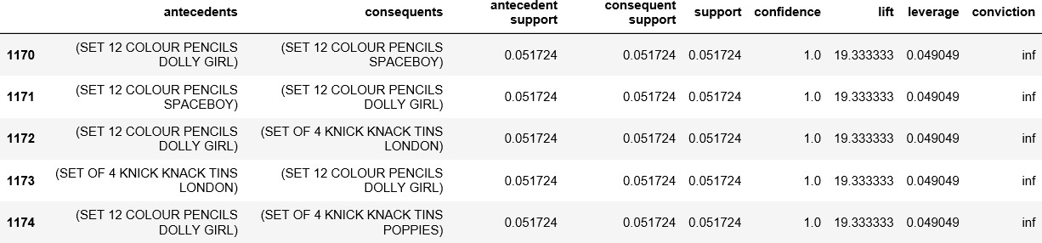

On analyzing the association rules for Portuguese transactions, it is observed that Tiffin sets (Knick Knack Tins) and color pencils. These two products typically belong to a primary school going kid. These two products are required by children in school to carry their lunch and for creative work respectively and hence are logically make sense to be paired together.

Sweden:

frq_items = apriori(basket_Sweden, min_support = 0.05, use_colnames = True) rules = association_rules(frq_items, metric ="lift", min_threshold = 1)
rules = rules.sort_values(['confidence', 'lift'], ascending =[False, False]) print(rules.head())
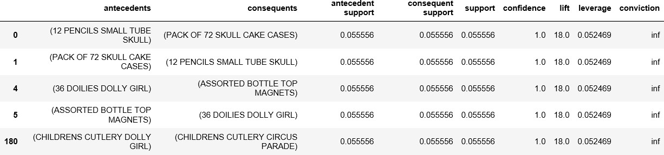

On analyzing the above rules, it is found that boys’ and girls’ cutlery are paired together. This makes practical sense because when a parent goes shopping for cutlery for his/her children, he/she would want the product to be a little customized according to the kid’s wishes.

Note: please make sure you save your python program to practice at your own independent study time. Do some research and try some other dataset on apriori algorithms to see rule association between data attributes.

You may be looking ahead to applying MBS in your final year projects, looks for other literature and examples where it applied to find the hidden rule associations from raw transactional data and adjust parameters for minimum support and confidence to filter out most important rules to create strategies.

Your Task: If you have completed this tutorial, Can you do some research to find a relevant dataset to apply MBS?

